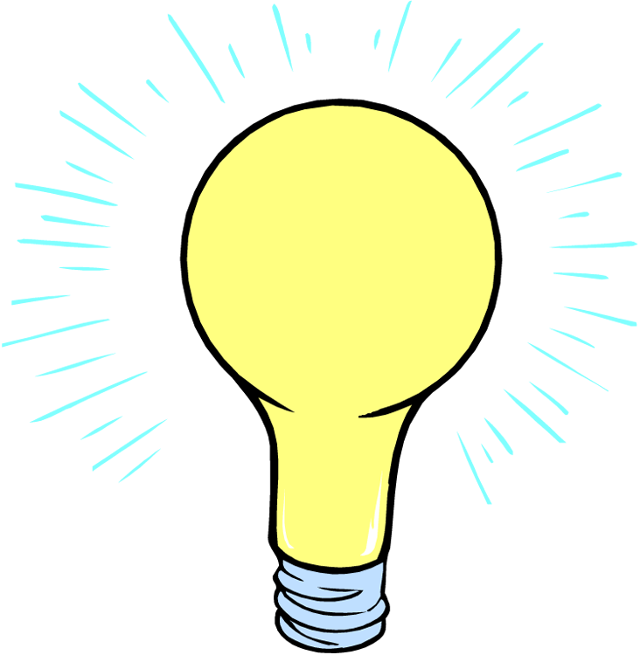
light
A form of energy that can be seen.
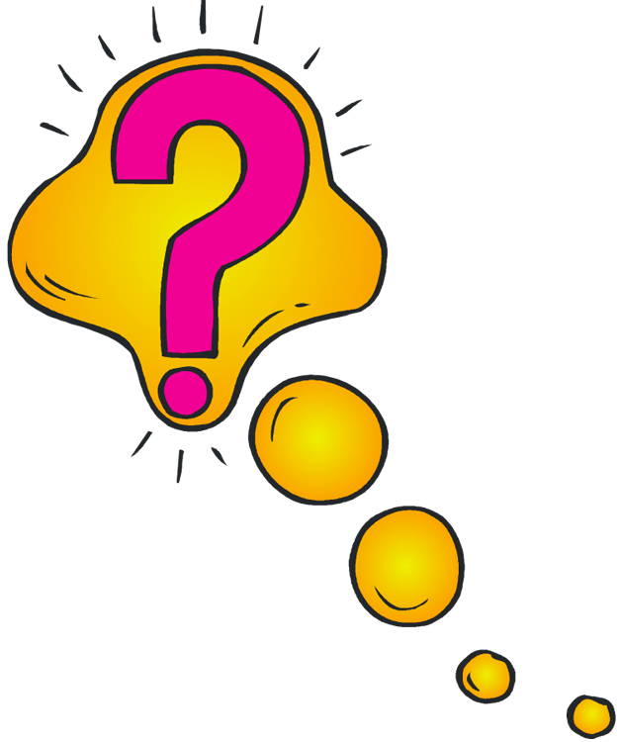
investigative question
A question that describes what you are trying to discover.
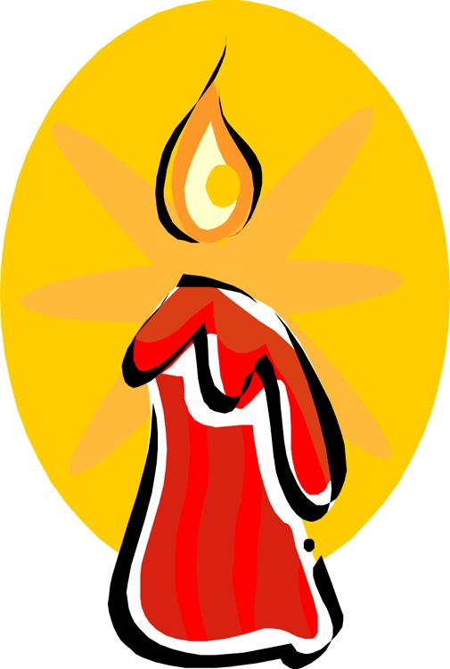
emit
To give off light.
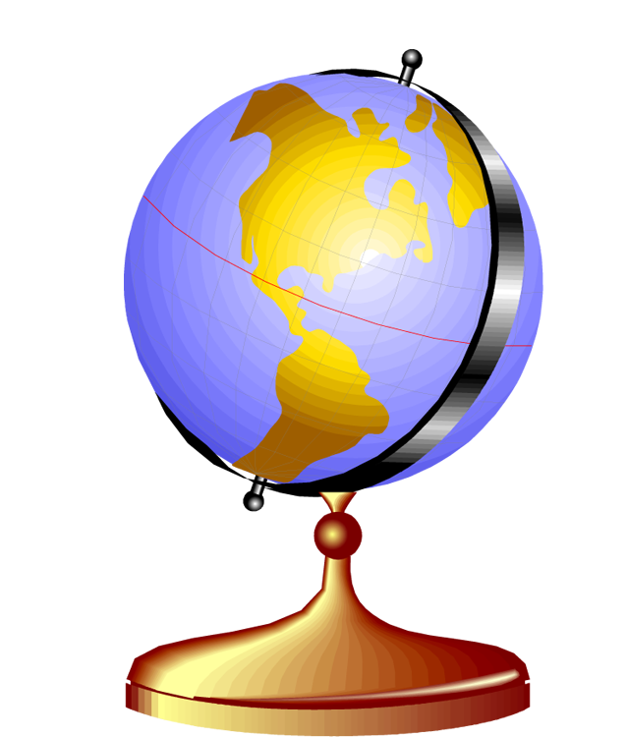
model
A representation of something that is similar to the real thing in many ways, but different in some ways.
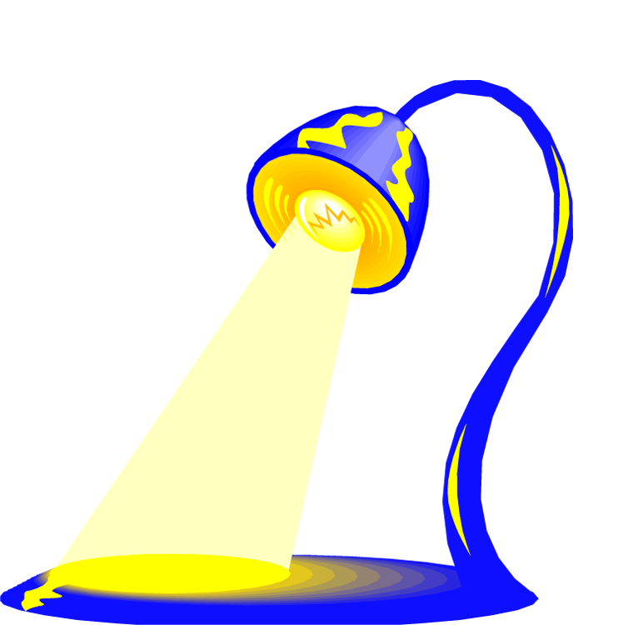
illuminate
To shine light on something.
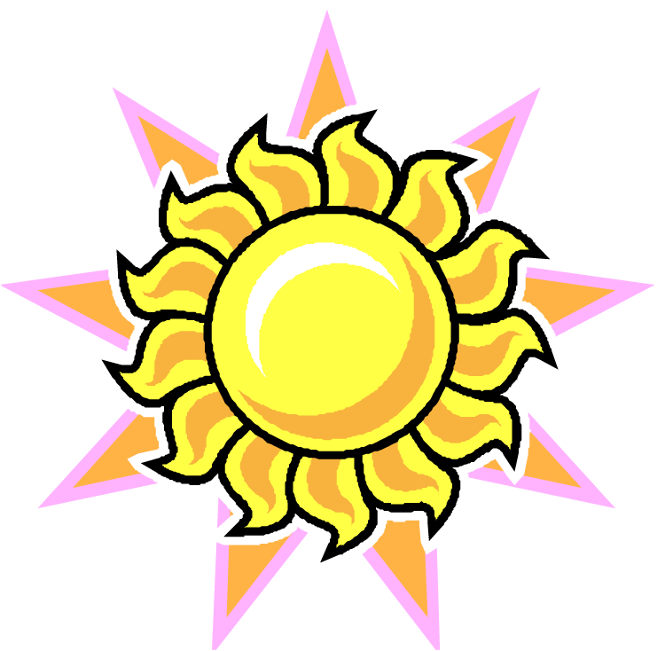
light source
bounce
An object that emits its own light.
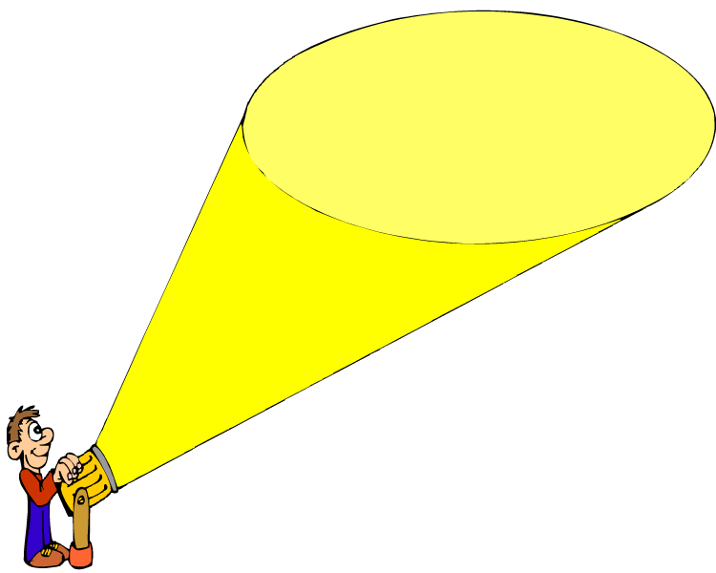
illumination
The light falling on an area.
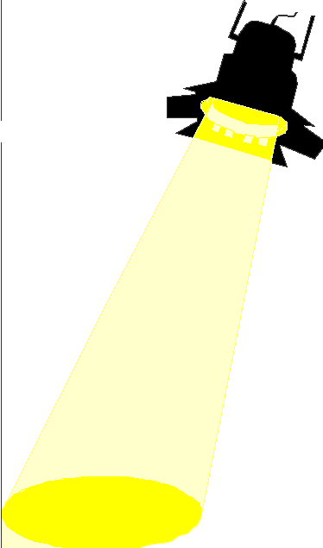
light beam
Light rays all going in one direction.
A way of describing how light changes direction after hitting an object.
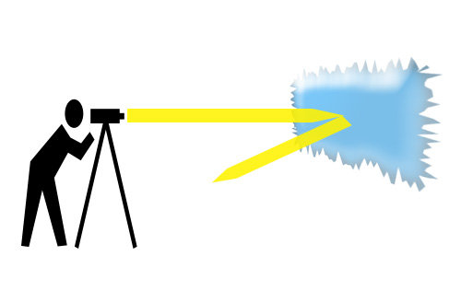
reflect
To bounce off something.
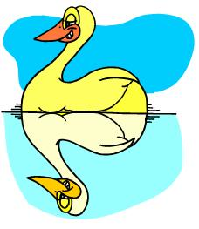
mirror-like reflection
When light bounces back towards its source, in the opposite direction.
scatter
What happens when light bounces off an object in many directions.
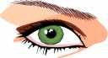 iris
The round, colored part of the eye.
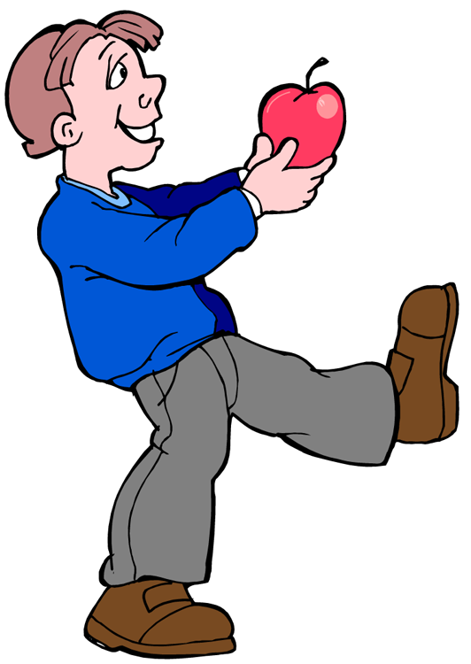
vision
The sense that lets people know what an object looks like.
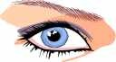
pupil
The hole in the center of the iris where light passes through. The size of the pupil changes in response to light.
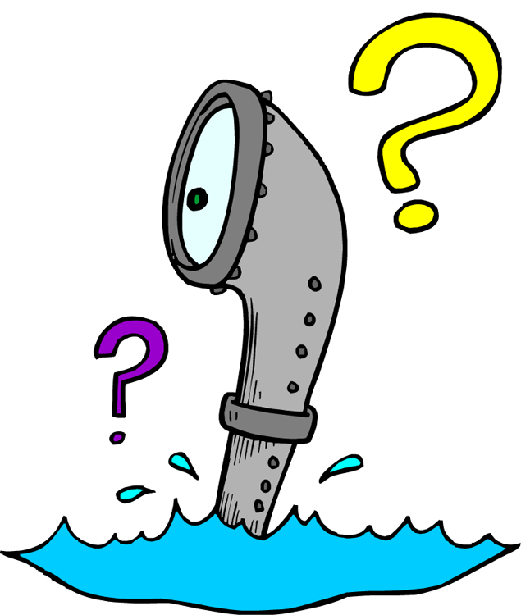
periscope
A viewing device that lets you look around corners or see out from behind objects.

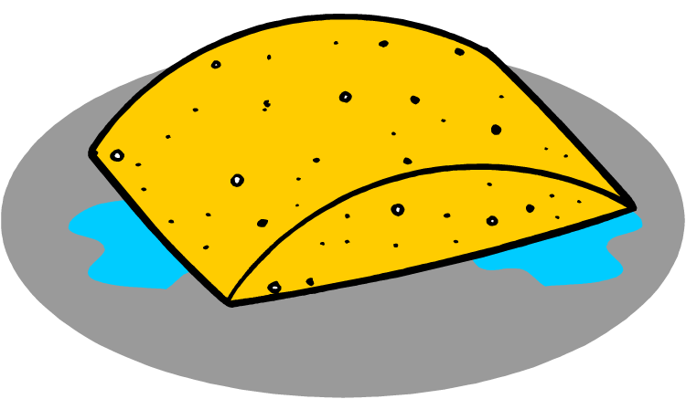
absorb
The way that one material takes in another material.
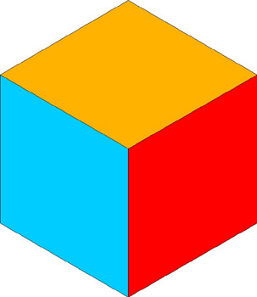
opaque
Something that does not allow any light to pass through it.
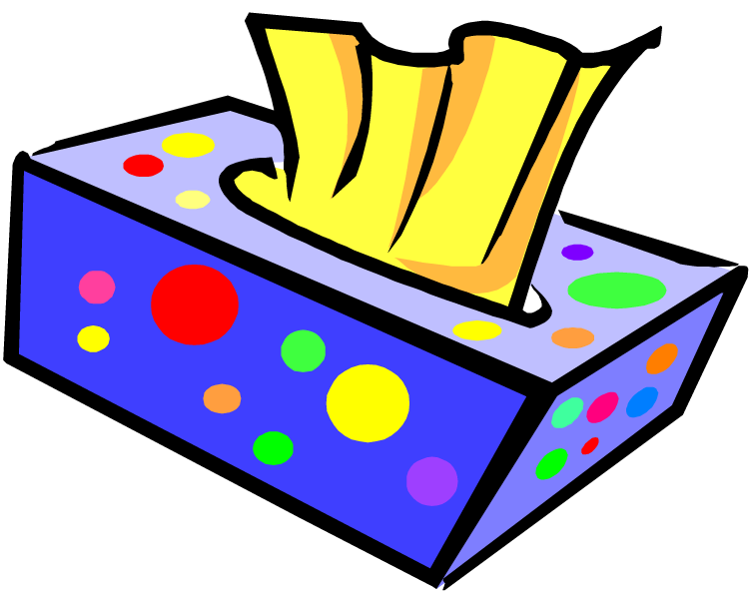
translucent
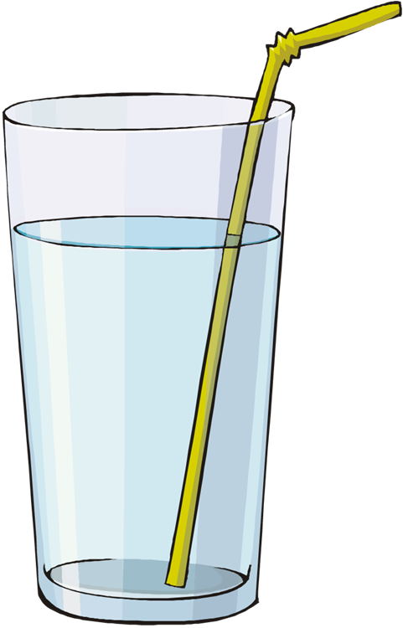
transparent
Something that allows some, but not all, light to pass through it.
Something that allows most light to pass through it.
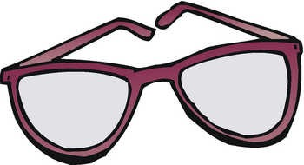
lens
A curved piece of glass or plastic that changes the direction of light passing through it.
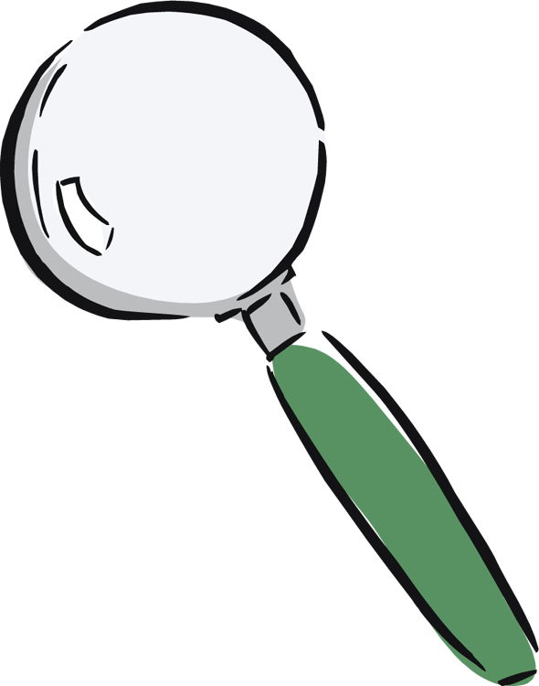
magnifying lens
A lens that makes objects look bigger.
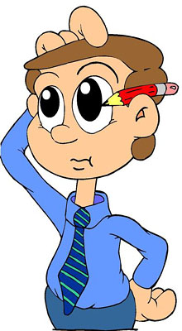
criteria
Reasons for a decision.
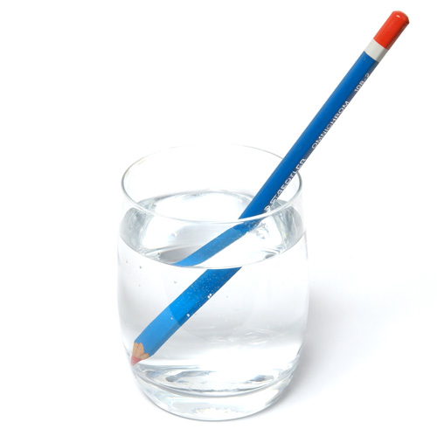
refract
When light changes direction after passing from one material (for example, air) to another (for example, water).
kinesthetic
Using bodily movements to express something.

A three-dimensional model of something.
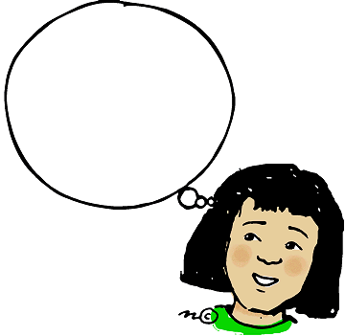
mental model
A model someone is thinking about in their mind.
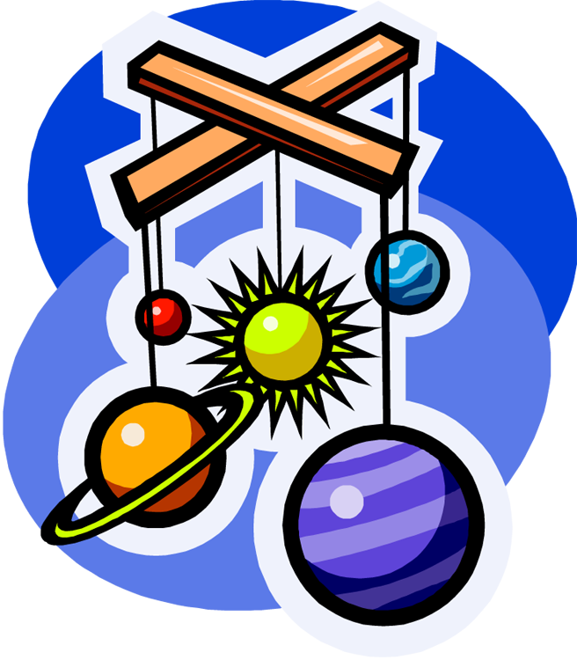
physical model
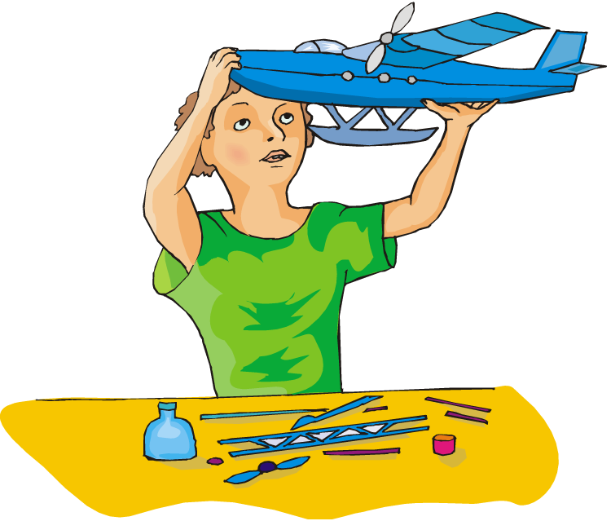
model
A representation of something that is similar to the real thing in many ways, but different in some ways.
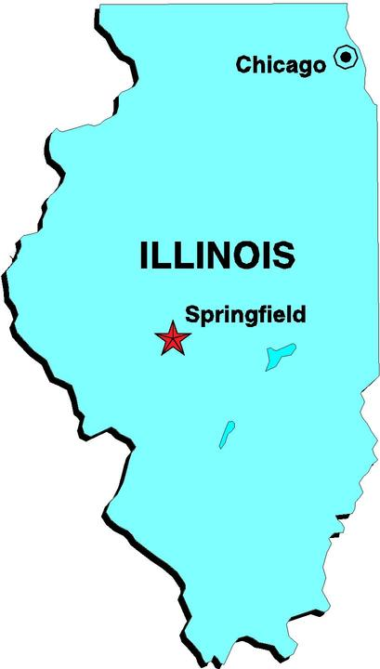
pictoral model
A two-dimensional model of something.

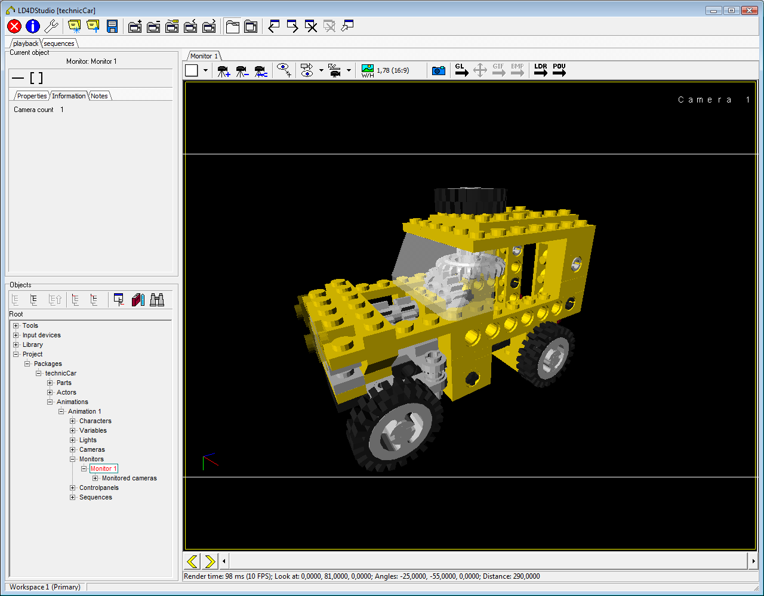
digital model
An animated model of something.

