Light Review Guide Part 2

1. What happens to light when it hits a mirror? ___________________________________________________
_________________________________________________________________________________________________________
2. Draw a picture of light shining from a flashlight onto a smooth piece of foil.

3. Draw a picture of light shining from a flashlight onto crumpled foil.

4. What happens when light hits the pupil of your eye? __________________________________________

5. How are we able to see? _________________________________________________________________________
_______________________________________________________________________________________________________

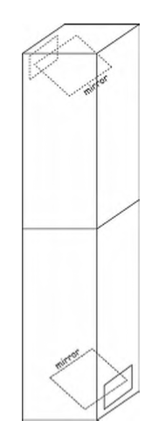
6. Draw a picture of an object at the top of the
periscope and an eye at the bottom of the periscope.
Draw arrows to show the way light travels through
the periscope.

7. Describe what happens to light from a flashlight when it shines on the objects in the examples below. In you answers be sure to include:
- words: transparent, translucent, or opaque
- pictures and arrows: show what happens to the light when it shines on each object.

When the light shines on thick cardboard…

When the light shines on clear plastic wrap…

When the light shines on tissue paper…

8. List a few materials that you could use to make a classroom as dark as possible. Explain why these would work best. _______________________________________________________________________
________________________________________________________________________________________________________
________________________________________________________________________________________________________
________________________________________________________________________________________________________

9. List a few materials that you would not use to make a classroom as dark as possible. Explain why these would not work very well. ____________________________________________________
________________________________________________________________________________________________________
________________________________________________________________________________________________________
________________________________________________________________________________________________________

10. Define the following words. Use “most,” “some,” or “none” in your definition.
a. transparent _______________________________________________________________________________ _________________________________________________________________________________________________
b. translucent ________________________________________________________________________________ _________________________________________________________________________________________________
c. opaque _____________________________________________________________________________________ _________________________________________________________________________________________________

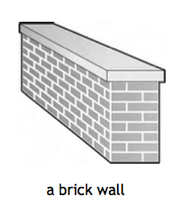
11. Use arrows to show and words to describe what happens to light when it shines on these objects.

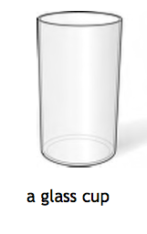

11. How are we able to see transparent objects? _________________________________________________
_________________________________________________________________________________________________________
_________________________________________________________________________________________________________

12. Describe what happens when light passes through air and water. (Hint: think about the pencil experiment.) ________________________________________________________________________________
_________________________________________________________________________________________________________

