Light Review Guide Part 1

1. Give the definition for the word emit. ___________________________________________________________
2. List five objects that emit light. __________________________________________________________________
3. List three objects that do not emit light. ________________________________________________________
4. What do you need in order to see objects? _____________________________________________________
5. If you wanted to light up a large area would you want to use a lamp with a shade or a
lamp without a shade? Explain your choice. ____________________________________________________
_____________________________________________________________________________________________________________________________________________________________________________________________________________________________________________________________________________________________________________________
6. Look at the picture below. Will light pass through all four of the holes. Explain why or why not.

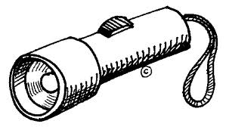

_____________________________________________________________________________________________________________________________________________________________________________________________________________________________________________________________________________________________________________________
_____________________________________________________________________________________________________________________________________________________________________________________________________________________________________________________________________________________________________________________
8. Does light travel in a curved, straight, or zig-zag direction? ________________________________
9. Draw a picture of a flashlight. Use arrows to show how the light travels out of the flashlight.

10. Draw a picture of a light bulb. Use arrows to show how the light travels out of the light bulb.

11. Look at the picture below. Describe how the girl sees the cat. Include the words source, bounce, and eye in your description. Draw arrows on the picture to show how light travels. ________________________________________________________________________________________
______________________________________________________________________________________________________________________________________________________________________________________________________________
_____________________________________________________________________________________________________________________________________________________________________________________________________________________________________________________________________________________________________________________
